**CENWP-ODJ7/5/2023**

**MEMORANDUM FOR THE RECORD**

**SUBJECT: *23JDA26 American White Pelicans Foraging at SFL Entrances***

On Thursday 29 June 2023, at approximately 0700, 12-American White Pelicans (AWPE) were observed foraging at JDA south fish ladder (SFL) entrances NE-1 and NE-2 for the first time. Since then, numbers have steadily increased. On Wednesday 5 July 2023 there were 120-AWPE at NE-1 and NE-2 (see Figure 1). In addition, 35-AWPE were observed foraging in SE-1. In 1-week, behavior has switched from almost exclusively spill based foraging (~100%) to primarily ladder entrance foraging (155-at entrances vs. 81-in spill flow).

Shad, sockeye, Chinook, and steelhead are all passing the JDA SFL (see Table 1). In an attempt to aid salmonid passage, NE-1 and NE-2 were moved to their lower limits.

Future and Preventative Measures – Continue monitoring the areas for AWPE behavior and try to identify fish species taken.

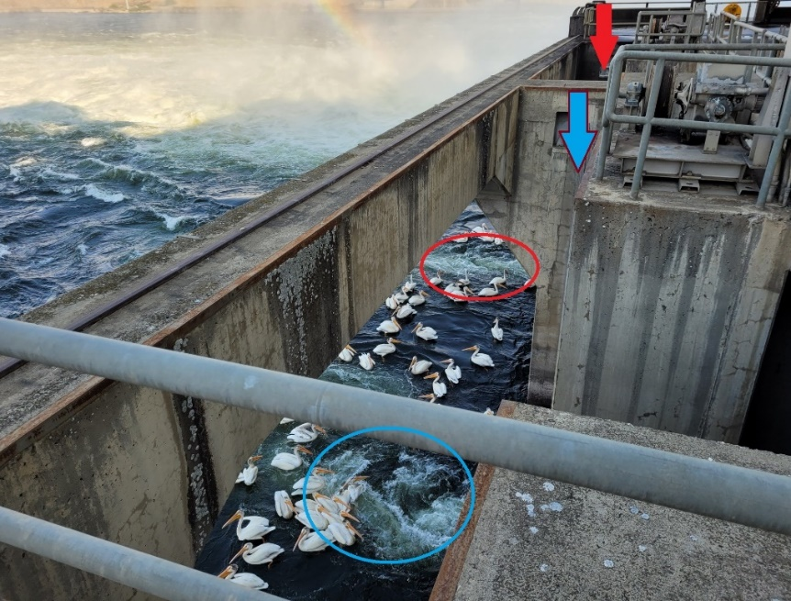

Figure 1: American white pelicans foraging at JDA SFL entrances NE-1 and NE-2. The blue arrow shows entrance NE-1, and the red arrow is entrance NE-2. The attraction flows are circled for reference (NE-1: blue, NE-2: red).

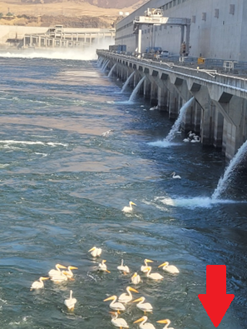

Figure 2: American white pelicans foraging at SE-1 and along the powerhouse. Red arrow indicates approximate SE-1 location.

Table 1: JDA SFL counts from 6/29/23 – 7/4/23, and Bonneville shad counts for the same time.

|  |  |  |  |  |
| --- | --- | --- | --- | --- |
| Date | Sockeye | Chinook | Steelhead | Bonn Shad |
| 6/29/2023 | 10,505 | 955 | 32 | 59,399 |
| 6/30/2023 | 13,129 | 1,440 | 54 | 47,797 |
| 7/1/2023 | 13,019 | 1,522 | 52 | 45,432 |
| 7/2/2023 | 13,678 | 1,380 | 107 | 38,230 |
| 7/3/2023 | 12,147 | 1,259 | 79 | 40,587 |
| 7/4/2023 | 11,885 | 986 | 87 | 33,885 |

Sincerely,

JDA Project Fisheries

Comments from others –

-----Original Message-----

**NOAA Fisheries/JDA Fisheries**

---------- Forwarded message ---------

From: Christopher Magel - NOAA Federal <[chris.magel@noaa.gov <mailto:chris.magel@noaa.gov](mailto:chris.magel@noaa.gov%20%3cmailto:chris.magel@noaa.gov)> >

Date: Tue, Jul 18, 2023 at 9:21 AM

Subject: Fwd: FPOM: Official Coordination - 23JDA25-27 memos

To: Lynne Krasnow - NOAA Federal <[lynne.krasnow@noaa.gov <mailto:lynne.krasnow@noaa.gov](mailto:lynne.krasnow@noaa.gov%20%3cmailto:lynne.krasnow@noaa.gov)> >

See below for reports from FPOM,

I thought, at the last FPOM, it was determined that more involved hazing could commence, especially given the proximity to the ladders?

What are next steps if initiation needs to happen?

Chris

-----Original Message-----  
From: Ricketts, Laura A CIV USARMY CENWP (USA) <Laura.A.Ricketts@usace.army.mil>   
Sent: Thursday, July 20, 2023 1:40 PM  
To: Mackey, Tammy M CIV USARMY CENWP (USA) <Tammy.M.Mackey@usace.army.mil>; Lotspeich, Michael D CIV USARMY CENWP (USA) <Michael.D.Lotspeich@usace.army.mil>; Grosvenor, Eric G CIV USARMY (USA) <Eric.Grosvenor@usace.army.mil>  
Subject: RE: [URL Verdict: Neutral][Non-DoD Source] Fwd: FPOM: Official Coordination - 23JDA25-27 memos

Yes, they started hazing pelicans last Friday. Unfortunately the pelicans don't seemed too bothered by the hazing so far and we still have a high number of them in the tailrace. On a brighter note, the experimental tori line that was installed at one of the entrances to the south fish ladder is working very well, and pelican numbers feeding there have dropped substantially, from 100+ to only a couple occasionally.

Laura Ricketts

Fish Biologist

USACE John Day Dam

541-739-1065

[Laura.A.Ricketts@usace.army.mil](mailto:Laura.A.Ricketts@usace.army.mil)

**Yakama Nation/JDA Fisheries**

From: Grosvenor, Eric G CIV USARMY (USA) <[Eric.Grosvenor@usace.army.mil](mailto:Eric.Grosvenor@usace.army.mil)>

Sent: Tuesday, July 18, 2023 11:00 AM

To: Ralph Lampman <[lamr@yakamafish-nsn.gov](mailto:lamr@yakamafish-nsn.gov)>; Mackey, Tammy M CIV USARMY CENWP (USA) <[Tammy.M.Mackey@usace.army.mil](mailto:Tammy.M.Mackey@usace.army.mil)>; Macdonald, Jacob B CIV USARMY CENWP (USA) <[Jacob.Macdonald@usace.army.mil](mailto:Jacob.Macdonald@usace.army.mil)>; Tackley, Sean C CIV USARMY CENWD (USA) <[Sean.C.Tackley@usace.army.mil](mailto:Sean.C.Tackley@usace.army.mil)>

Subject: RE: [URL Verdict: Neutral][Non-DoD Source] Re: FPOM: Official Coordination - 23JDA25-27 memo

Hi Ralph,

We can certainly add the Pacific Lamprey numbers to the table. I can’t say for certain what’s going on in the evening as no one is here. I’ll ask our security officer if we have any video footage we could review, I’m curious myself. We haven’t seen any pelicans around the entrances since the shad numbers have dropped. I think the tori line we deployed helped out quite a bit too.

USDA started pyro hazing over the weekend and the pelicans seem to have adapted pretty quickly to flying into areas the boat can’t reach in our boater restricted zone.

I’ll let you know if we find anything from the video footage.

Take care,

Eric Grosvenor

Supervisory Fish Biologist

USACE John Day Dam

O 541 739 1063

C 541 499 7057

From: Ralph Lampman <[lamr@yakamafish-nsn.gov <mailto:lamr@yakamafish-nsn.gov](mailto:lamr@yakamafish-nsn.gov%20%3cmailto:lamr@yakamafish-nsn.gov)> >

Sent: Tuesday, July 18, 2023 9:23 AM

To: Mackey, Tammy M CIV USARMY CENWP (USA) <[Tammy.M.Mackey@usace.army.mil <mailto:Tammy.M.Mackey@usace.army.mil](mailto:Tammy.M.Mackey@usace.army.mil%20%3cmailto:Tammy.M.Mackey@usace.army.mil)> >; Grosvenor, Eric G CIV USARMY (USA) <[Eric.Grosvenor@usace.army.mil <mailto:Eric.Grosvenor@usace.army.mil](mailto:Eric.Grosvenor@usace.army.mil%20%3cmailto:Eric.Grosvenor@usace.army.mil)> >; Macdonald, Jacob B CIV USARMY CENWP (USA) <[Jacob.Macdonald@usace.army.mil <mailto:Jacob.Macdonald@usace.army.mil](mailto:Jacob.Macdonald@usace.army.mil%20%3cmailto:Jacob.Macdonald@usace.army.mil)> >; Tackley, Sean C CIV USARMY CENWD (USA) <[Sean.C.Tackley@usace.army.mil <mailto:Sean.C.Tackley@usace.army.mil](mailto:Sean.C.Tackley@usace.army.mil%20%3cmailto:Sean.C.Tackley@usace.army.mil)> >

Subject: [URL Verdict: Neutral][Non-DoD Source] Re: FPOM: Official Coordination - 23JDA25-27 memos

Hi Tammy, (cc: others)

For the White Pelican report, I'm sure they are targeting Pacific Lamprey as well (would be good to include their #s in the table).

Are they there just during the day time hours?

Shad, sockeye, Chinook, and steelhead are all passing the JDA SFL (see Table 1). In an attempt to aid salmonid passage, NE-1 and NE-2 were moved to their lower limits.

~Warm Regards~

Ralph Lampman

COLUMBIA RIVER| Honor. Protect. Restore

Yakama Nation FRMP, Pacific Lamprey Project

[lamr@yakamafish-nsn.gov](mailto:lamr@yakamafish-nsn.gov) <<mailto:lamr@yakamafish-nsn.gov>>

509-388-3871

<Blockedhttps://ci3.googleusercontent.com/mail-sig/AIorK4ym0GVt_-m9okcUg1HieaIBWhFGPGf_mlBDopkd0rAb3zadzuuiwV64iw8BC-cK8aP_73afBY4>